**Test Case 8**

**System:** Bench

**Description:** Test that the user is able to report a suspicious person in the chat.

**Severity:** 2

**Instructions**

**Test 1**

1. Start the Bench application.
2. Click the button “Login” on the navigation bar.
3. Enter the email “user1@gmail.com” into the text field labeled “Email address”.
4. Enter the password “12345678” into the field labeled “Password”.
5. Click the button “Login” below the field.
6. After the screen has loaded, click on the button “Chat” on the navigation bar.
7. Click on any of the existing chat panels listed on the left sidebar.
8. Click on the profile photo on the top left corner of the chat room.

**Expected Result:** There should exist a report button for users to report a person.

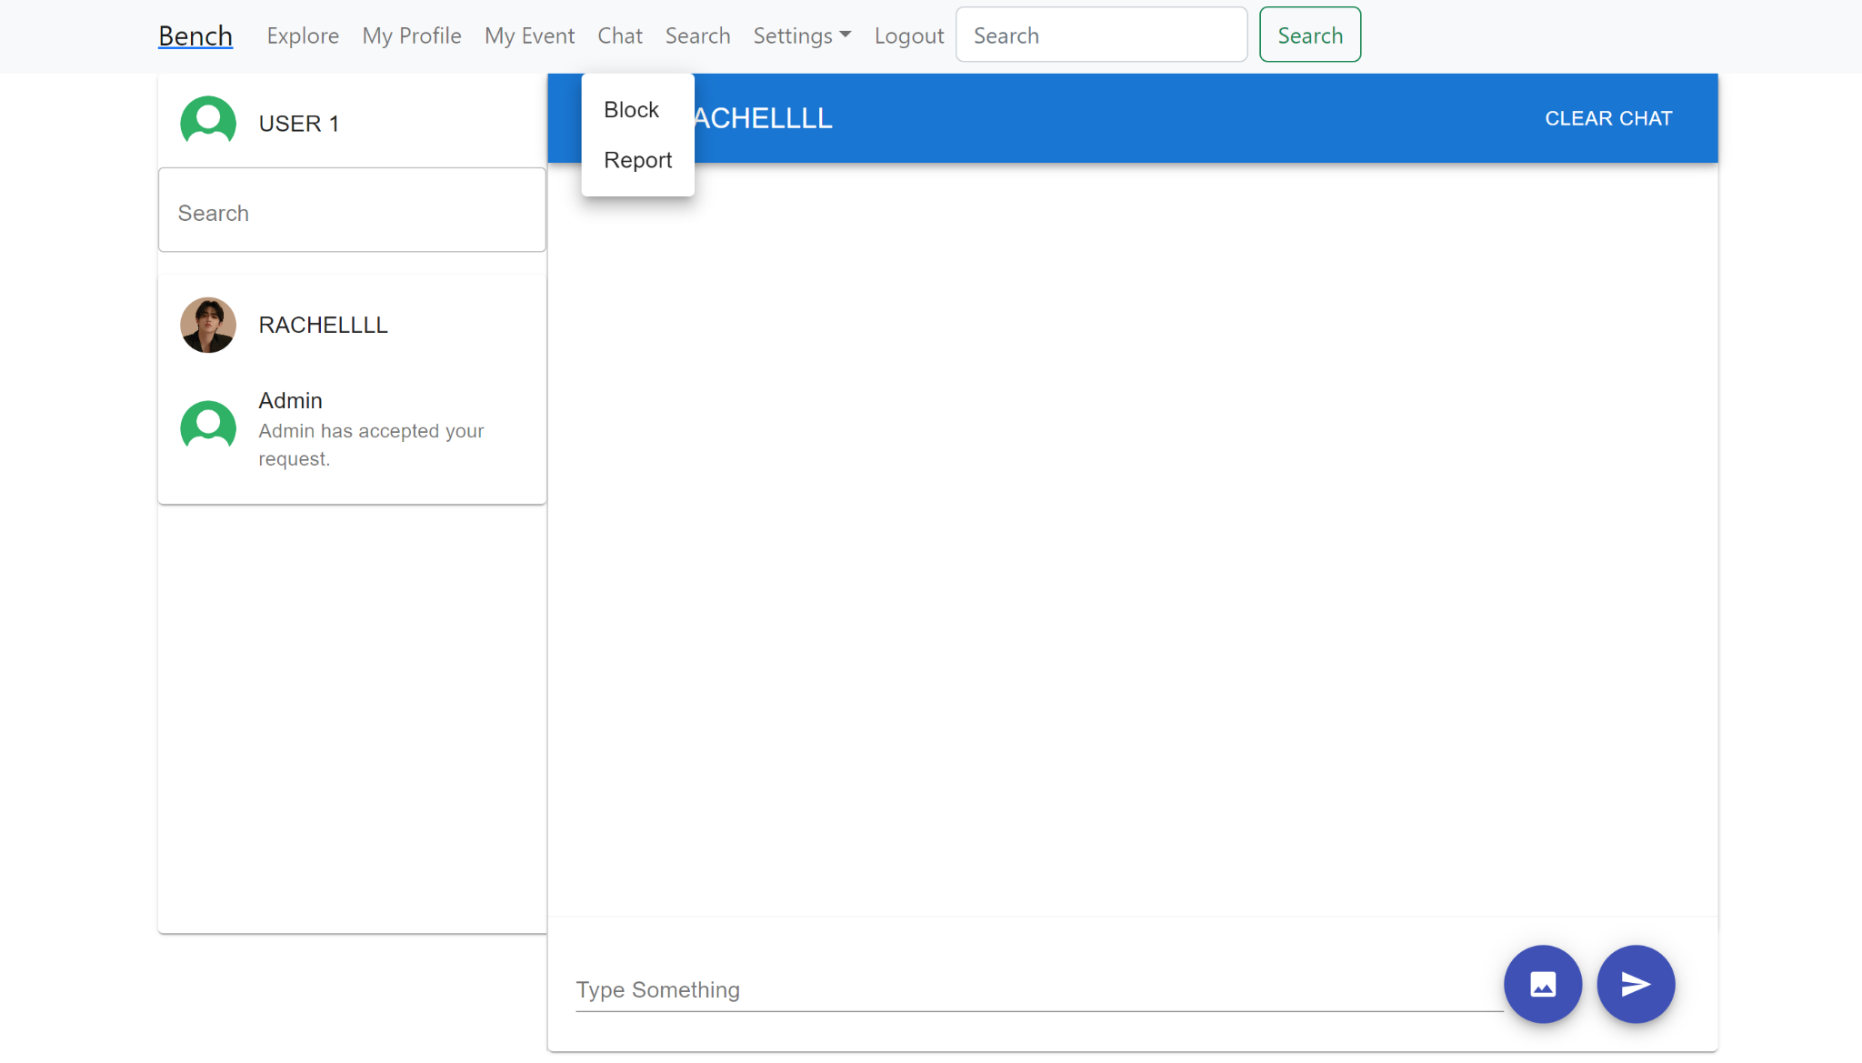

**Test 2**

1. Start the Bench application.
2. Click the button “Login” on the navigation bar.
3. Enter the email “user1@gmail.com” into the text field labeled “Email address”.
4. Enter the password “12345678” into the field labeled “Password”.
5. Click the button “Login” below the field.
6. After the screen has loaded, click on the button “Chat” on the navigation bar.
7. Click on any of the existing chat panels listed on the left sidebar.
8. Click on the profile photo on the top left corner of the chat room.
9. Click on the button “Report”.
10. Click on the button “OK” on the alert.

**Expected Result:** A window should pop up to open the current user’s default email with a pre-formatted email ready to be sent to the administrator email address, which allows the current user to send a report.

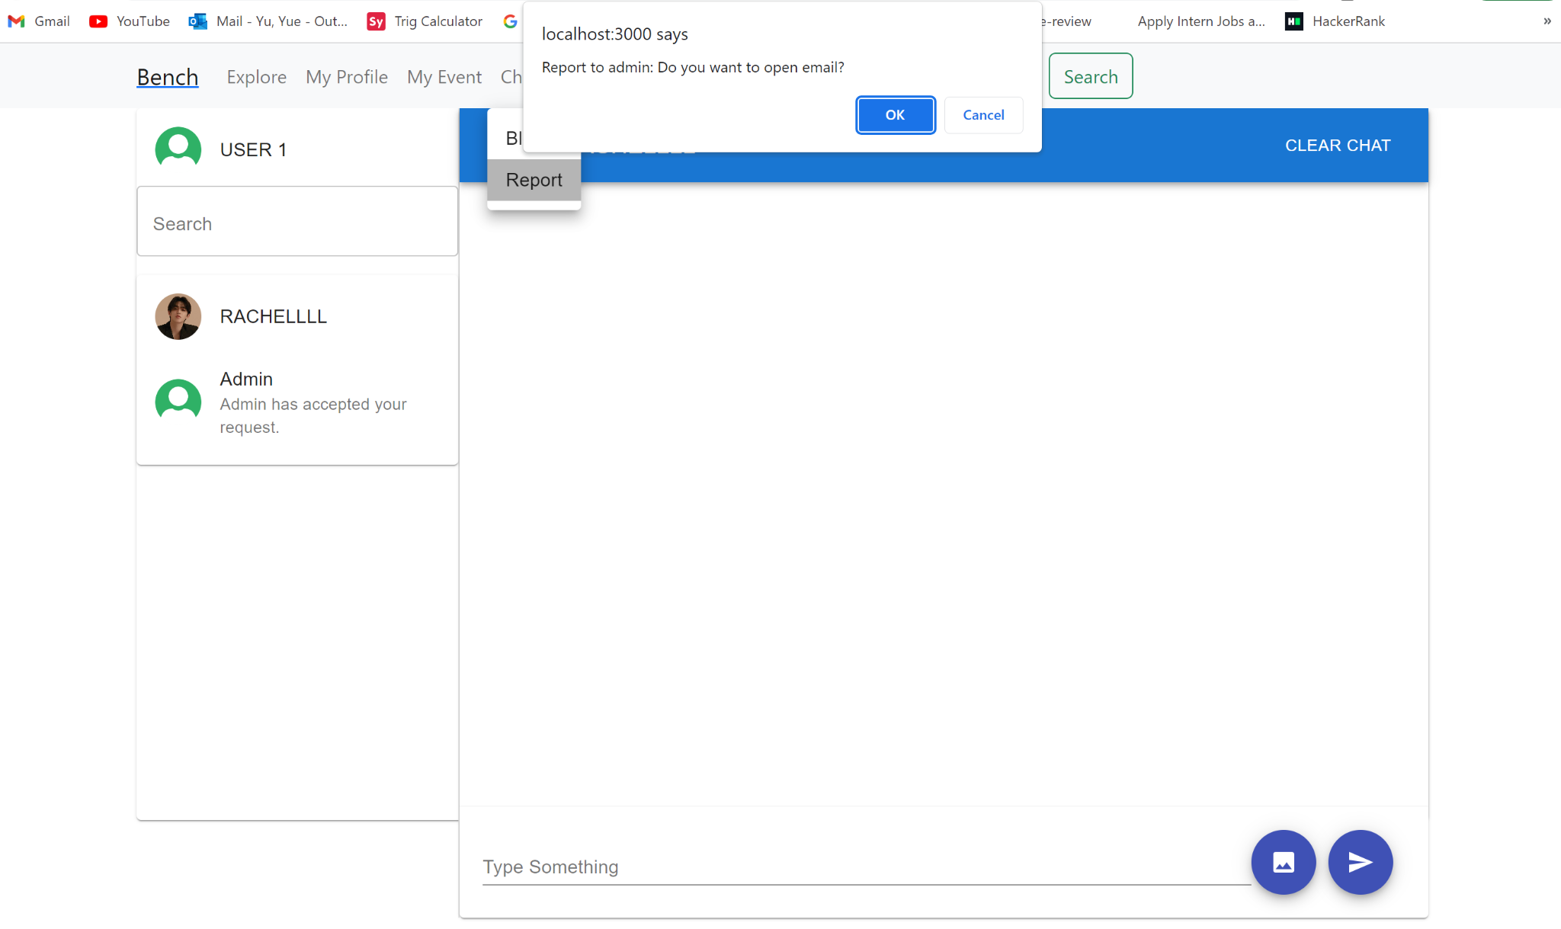

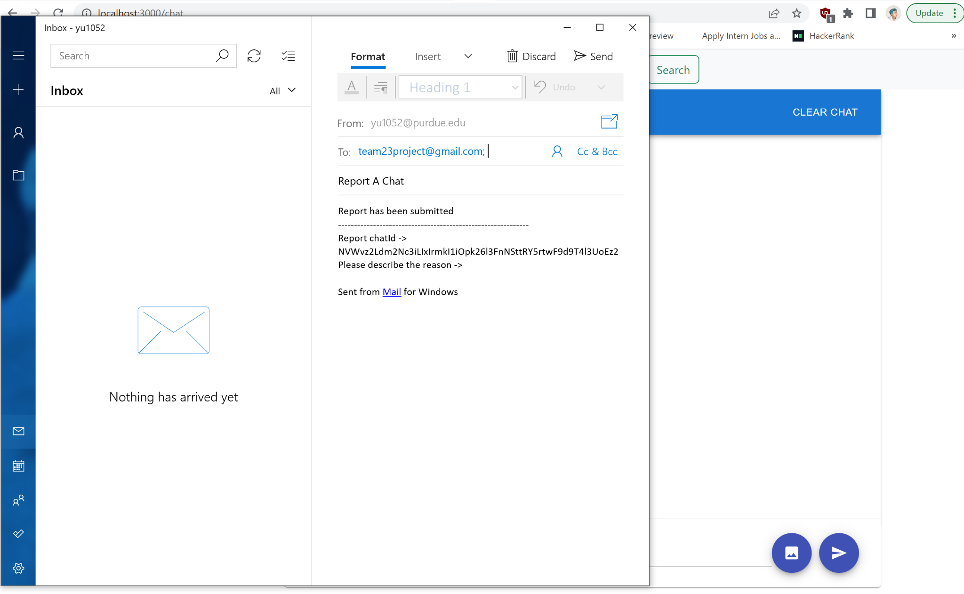

**Test 3**

1. Start the Bench application.
2. Click the button “Login” on the navigation bar.
3. Enter the email “user1@gmail.com” into the text field labeled “Email address”.
4. Enter the password “12345678” into the field labeled “Password”.
5. Click the button “Login” below the field.
6. After the screen has loaded, click on the button “Chat” on the navigation bar.
7. Click on any of the existing chat panels listed on the left sidebar.
8. Click on the profile photo on the top left corner of the chat room.
9. Click on the button “Report”.
10. Click on the button “OK” on the alert.
11. A window should pop up to open the current user’s default email with a pre-formatted email ready to be sent to the administrator email address.

**Expected Result:** The user should be offered the option to describe the report reason in the pre-formatted email.



**Test 4**

1. Start the Bench application.
2. Click the button “Login” on the navigation bar.
3. Enter the email “user1@gmail.com” into the text field labeled “Email address”.
4. Enter the password “12345678” into the field labeled “Password”.
5. Click the button “Login” below the field.
6. After the screen has loaded, click on the button “Chat” on the navigation bar.
7. Click on any of the existing chat panels listed on the left sidebar.
8. Look at the profile photo and the username on the top left corner of the chat room before reporting this user.
9. Click on the profile photo on the top left corner of the chat room.

**Expected Result:** By looking at both the profile photo and the username of the person before clicking on the exact profile photo, the user should be able to identify and distinguish which user they are reporting.

